**PAGE REPLACEMENT**

Page Replacement happens when a requested page is not present in the main memory and the available space is not sufficient for allocation to the requested page. Page Replacement Algorithm decides which page to remove, also called swap out when a new page needs to be loaded into the main memory.  These algorithms are evaluated by running them on a particular string of memory reference and computing the number of page faults. There are many different page replacement algorithms.

1)First-in first out(FIFO)

2) Optimal policy

3)Least Recently used(LRU)

4) Least Frequently used(LFU)

5)Most Frequently used(MFU)

6) Last-in first out(LIFO)

7) Most Recently used(MRU)

**1)FIFO:**

It is a very simple way of Page replacement and is referred to as First in First Out. This algorithm mainly replaces the oldest page that has been present in the main memory for the longest time.

In this algorithm, the OS maintains a queue that keeps track of all the pages in memory, with the oldest page at the front and the most recent page at the back. When there is a need for page replacement, the FIFO algorithm, swaps out the page at the front of the queue, that is the page which has been in the memory for the longest time.

**Advantages**

* Simple and easy to implement.
* Low overhead.

**Disadvantages**

* Poor performance.
* Doesn’t consider the frequency of use or last used time, simply replaces the oldest page.
* Suffers from Belady’s Anomaly(i.e. more page faults when we increase the number of page frames).

**Example:** Consider the page reference string of size 12: 1, 2, 3, 4, 1, 2, 5, 1, 2, 3,4,5 with frame size 3(i.e. maximum 3 pages in a frame). By using FIFO page replacement algorithm Find number of page Faults and page fault rate?

**Example:** Consider the page reference string of size 12: 1, 2, 3, 4, 1, 2, 5, 1, 2, 3,4,5 with frame size 4(i.e. maximum 4 pages in a frame). By using FIFO page replacement algorithm Find number of page Faults and page fault rate?

Example:Consider the page reference string of size 12: 1, 2, 3, 4, 5, 1, 3, 1, 6, 3, 2, 3 with frame size 4(i.e. maximum 4 pages in a frame). By using FIFO page replacement algorithm Find number of page Faults and page fault rate?

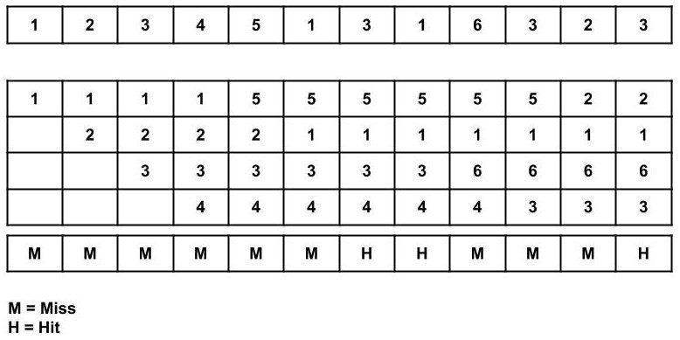

**Total Page Fault = 9**

**2)Optimal page replacement:**

Optimal Page Replacement algorithm is the best page replacement algorithm as it gives the least number of page faults. It is also known as OPT. In this algorithm, pages are replaced which would not be used for the longest duration of time in the future. The practical implementation of this algorithm is not possible because we cannot predict in advance those pages that will not be used for the longest time in the future.

***Advantages***

* Easy to Implement.
* Simple data structures are used.
* Highly efficient.

***Disadvantages***

* Requires future knowledge of the program.
* Time-consuming.

**Example:** Consider the page reference string of size 12: 1, 2, 3, 4, 1, 2, 5, 1, 2, 3,4,5 with frame size 3(i.e. maximum 3 pages in a frame). By using Optimal page replacement algorithm Find number of page Faults and page fault rate?

**Example:** Consider the page reference string of size 12: 1, 2, 3, 4, 5, 1, 3, 1, 6, 3, 2, 3 with frame size 4(i.e. maximum 4 pages in a frame). By using OPT page replacement algorithm Find number of page Faults and page fault rate?

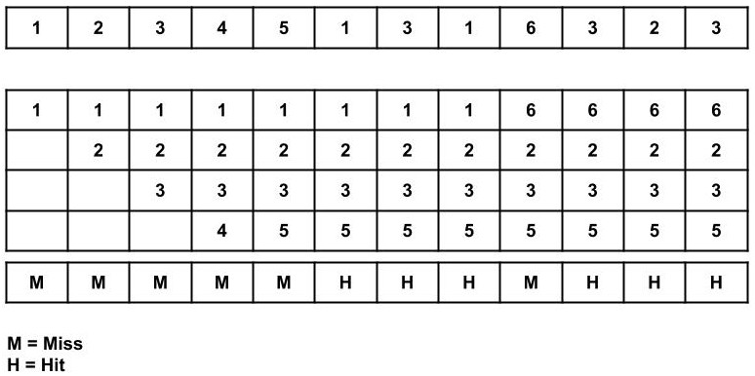

**Total Page Fault = 6**

**Page Fault ratio = 6/12**

**3)LRU:**

In LRU, whenever page replacement happens, the page which has not been used for the longest amount of time is replaced.

***Advantages***

* Efficient.
* Doesn't suffer from Belady’s Anomaly.

***Disadvantages***

* Complex Implementation.
* Expensive.
* Requires hardware support.

**Example:** Consider the page reference string of size 12: 1, 2, 3, 4, 1, 2, 5, 1, 2, 3,4,5 with frame size 3(i.e. maximum 3 pages in a frame). By using LRU page replacement algorithm Find number of page Faults and page fault rate?

**Example:** Consider the page reference string of size 12: 1, 2, 3, 4, 5, 1, 3, 1, 6, 3, 2, 3 with frame size 4(i.e. maximum 4 pages in a frame). By using LRU page replacement algorithm Find number of page Faults and page fault rate?

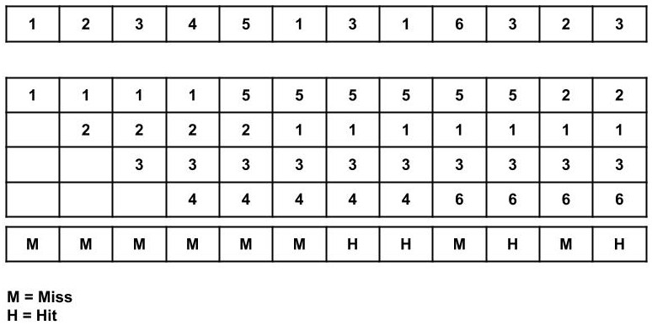

**Total Page Fault = 8**

**Page Fault ratio = 8/12**

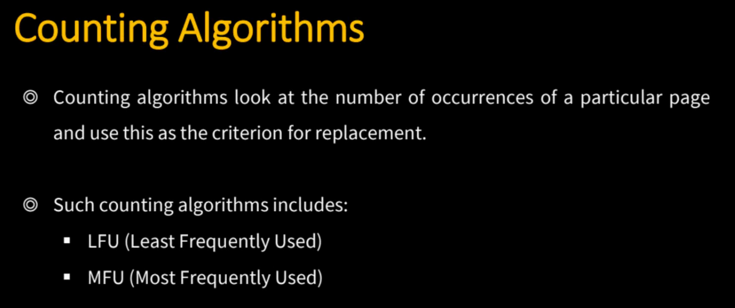

**4)LFU:**

LFU is one such page replacement policy in which the least frequently used pages are replaced. If the frequency of pages is the same, then the page that has arrived first is replaced first.

**Example:** Consider the page reference string of size 11: 1, 2, 0, 3,0, 4, 2, 3, 0, 3,2 with frame size 3(i.e. maximum 3 pages in a frame). By using LFU page replacement algorithm Find number of page Faults and page fault rate?

**5)MFU:**

MFU is one such page replacement policy in which the most frequently used pages are replaced. If the frequency of pages is the same, then the page that has arrived first is replaced first.

**Example:** Consider the page reference string of size 11: 1, 2, 0, 3,0, 4, 2, 3, 0, 3,2 with frame size 3(i.e. maximum 3 pages in a frame). By using MFU page replacement algorithm Find number of page Faults and page fault rate?

**6)LIFO:**

Last In First Out (LIFO) algorithm replaces the page that was last inserted into the main memory i.e. the most recent insertion.

**Example:** Consider the page reference string of size 12: 1, 2, 3, 4, 1, 2, 5, 1, 2, 3,4,5 with frame size 3(i.e. maximum 3 pages in a frame). By using LIFO page replacement algorithm Find number of page Faults and page fault rate?

**7)MRU:**

**MRU** page replacement algorithm is the counterpart to the LRU algorithm. Instead of replacing the least recently used page, MRU replaces the most recently used page.

**Example:** Consider the page reference string of size 12: 1, 2, 3, 4, 1, 2, 5, 1, 2, 3,4,5 with frame size 3(i.e. maximum 3 pages in a frame). By using Optimal page replacement algorithm Find number of page Faults and page fault rate?